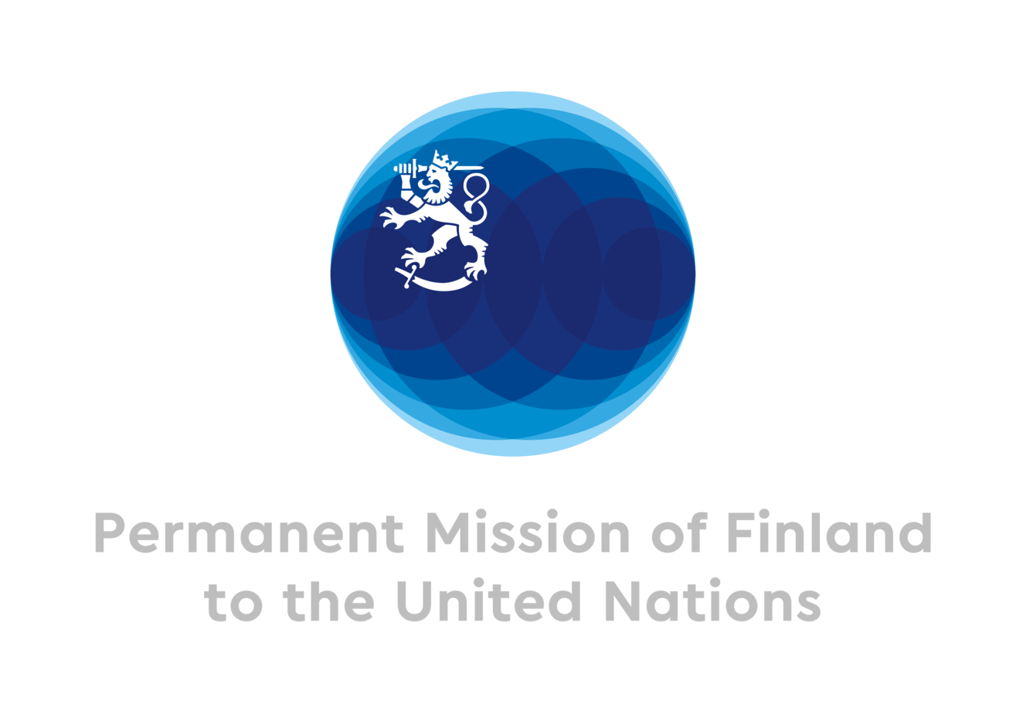
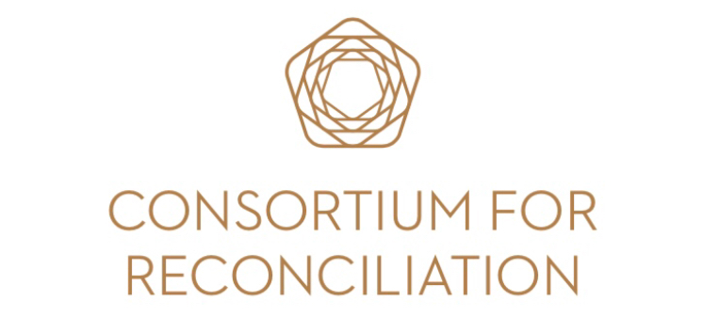
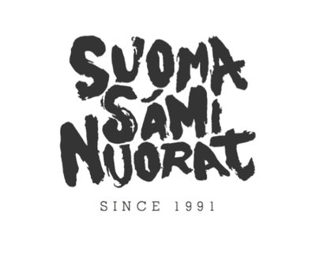
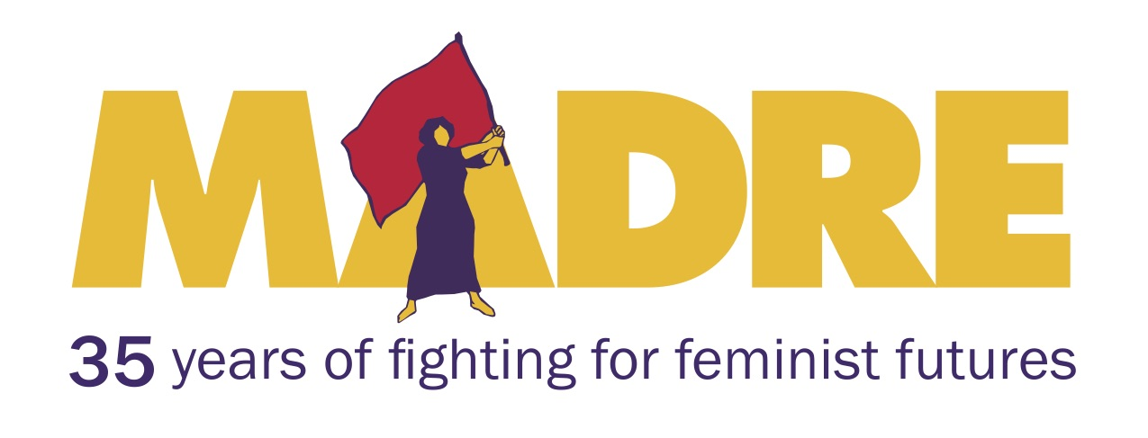
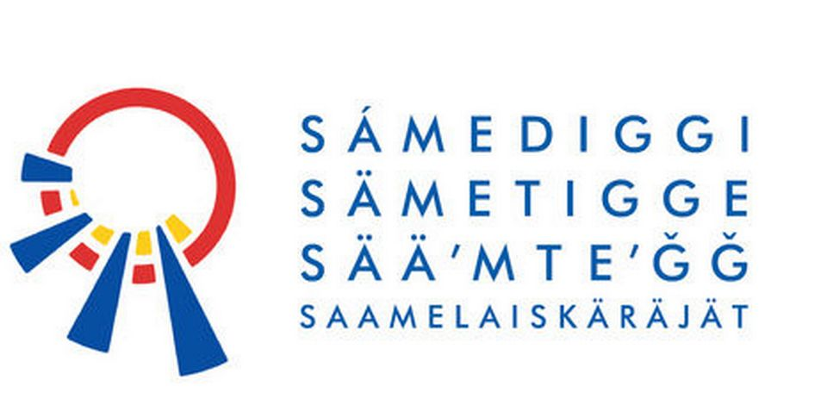

Truth and Reconciliation Commissions
and Indigenous Peoples

Sami Story-Telling and Healing in Finland

April 16, 2018, 1:15-2:45pm
Conference Room F, UNHQ
405 East 42nd Street, New York

The Sami Parliament, the Finnish Saami Youth Organization, MADRE, the Network for Religious and Traditional Peacemakers and the Consortium for Reconciliation, with the support of the Permanent Mission of Finland welcome you to a side event during the UN Permanent Forum on Indigenous Issues (UNPFII).

The event will be chaired by Eduardo Gonzalez, transitional justice expert and advisor to several truth-seeking processes led by indigenous peoples. Two presentations will be shared by Anne Nuorgam (Sami Parliament) and Ida-Maria Helander (Finnish Saami Youth Organization) and will highlight their perspectives on a possible truth and reconciliation process in Finland. Aili Keskitalo (Sami Parliament of Norway), Per-Olof Nutti (Sami Parliament of Sweden) and Tuomas Aslak Juuso (Sámi Parliament of Finland) will share how truth and reconciliation processes are progressing in Norway, Sweden and Finland.

Observations on reconciliation processes with indigenous peoples will be shared by Ms. Otilia Lux, former member of the UN-sponsored Commission on Historical Clarification in Guatemala and MADRE advisor.

Antti Pentikainen, independent advisor to the Sami truth and reconciliation process in Finland and convener of the Network for Religious and Traditional Peacemakers will give closing remarks.

Following these presentations time will be allowed for Q&A.

To RSVP for the event please email Annalisa Jackson at: annalisa.jackson@peacemakersnetwork.org

