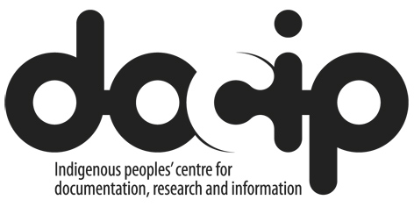

Friday, 15 July 2016
Workshop – Other UN Mechanisms, the 2030 Agenda,
and Rights-Based Advocacy Planning
in English, Spanish, French and Russian
10:00 – 13:00
Room 24 (XXIV), Building E, UN Palais des Nations, Geneva

Docip and the UN Voluntary Fund for Indigenous Peoples cordially invite you to the workshop, Other UN Mechanisms, the 2030 Agenda, and Rights-Based Advocacy Planning. This training session is open to all delegates.
10:00 – 11:00 Overview of UN mechanisms
Overview of key UN mechanisms relevant to indigenous peoples
UN advocacy opportunities for indigenous women
UN advocacy opportunities for indigenous persons with disabilities

11:00 – 11:10 10-minute break

11:10 – 12:00 The 2030 Agenda for Sustainable Development/ Sustainable Development Goals (SDGs)
Indigenous Peoples and the 2030 Agenda/SDGs: background, main issues and current advocacy opportunities
The 2030 Agenda and youth: issues and advocacy opportunities

12:00 – 12:10 10-minute break

12:10 – 13:00 Advocacy planning workshop
Making your rights-based advocacy plan
Deciding on your advocacy priorities using a rights-based approach, choosing where and with whom to pursue your priorities, and achieving targeted advocacy results
Exercise: Using the Docip document, 'Agenda of upcoming meetings and events of interest for indigenous peoples'
Wrap-up and closure of meeting

With the support of the European Union, the Sámediggi (Saami Parliament in Norway), the Swiss Agency for Development and Cooperation, the Canton of Geneva, the City of Geneva and the UN Voluntary Fund for Indigenous Peoples
http://www.docip.org

